Solution Development Design
  - Financials Deposit Import – EDI – Revision 1

Document Approval
Approver | Approved Date | Rejected Date | Comments

Part 1: Solution Deliverables
Note that any images displayed are for illustration purposes only and may not accurately reflect the final delivered results.

- Support importation of CSV file with a set format into a core product Financials Deposit.

In order to generate a core product deposit the following information must be obtained
- Customer (one or more can be specified)
- The bank account it being remitted into
- Amount of payment per customer
- Payment to specific invoices is optional, if no invoice is set to be paid OR the invoice being referenced does not exist, is already paid or in a state that prevents payment the funds will be treated as on the customer account.
- Other information that is optional are payment type, reference numbers, currency and comments

Breakout of File with required and optional fields

The file will contain the following fields:

“CustomerNo” – This will be assumed to equate to an existing Seradex customer via the customer code field. This can be optional if the source system the file is generated from does not have such a field. In this case the customer will be derived from the invoice.

*CustomerNo will not be keyed/captured. Leave blank for the csv file.

“Amount” – This will be the amount to apply to the customer, needs to be greater than zero.

*Amount is the amount paid. Positive and Negative amounts will be passed on the csv file.
- TS 08/17: The import sheet, in its current state, accepts only positive numbers (with the expectations that credit notes/discounts will be applied manually upon import). If negative numbers are provided on this import as a communication on customer remittance behavior, these entries must be removed prior to import into Seradex software and manually processed.
“PaymentTypeCode” - Optional up to 50 characters – Can be used to denote a payment type, for example from a credit card import if the card code is known such as VISA or MC, this can be used as the payment type on the deposit detail. Note if missing from the database the system will create a new payment type with the value both the code and description. This type will be created with the system code of “cash” and not a cheque type. If not supplied the deposit will use the default payment type used when creating a new core product deposit detail against a customer.
*PaymentTypeCode – Populate with Check for check payments ACH for ACH payments and Wire for Wire payments.

“PaymentTypeNo” – optional up to 50 characters. This can be used for a reference on the deposit detail to store information such as an authorization code or any other data that can be used for a reference to the source of the payment.

*PaymentTypeNo- Populate with Check number or ACH/Wire reference number. If not present, leave blank.

“Invoice” – This would equate to an existing Seradex invoice number. Please note while this is optional, if the customer number is not supplied the system will use this to find the customer for the deposit line. If the invoice is a valid Seradex invoice, if the invoice is not available to be paid such as cases where it was paid previously or credited, the deposit will still be created just the funds will be left on account.

*Invoice – Populate Invoice number provided by Remitter. If not present, leave blank. Default to 9’s for Force balanced transactions.
- TS 08/17: In the event that the invoice number is blank: as either a customer number or an invoice number are required for the import to succeed & properly allocate payments, this import sheet must be manually updated by Repacorp’s accounting team (to include customer number or invoice number) prior to importing into the system.
- TS 08/17: Force Balanced Transactions – as there is not built-in functionality with this import to address transactions that do not map to a valid invoice/customer number, this practice would be a signal to Repacorp’s accounting team that manual intervention is required for these lines. These records should be eliminated from sheet prior to importing into Seradex software.

“Comment” – optional, can be used to provide any additional information for the deposit detail. Any value here will be stored in the related AR payment’s memo field.
*Comment will not be keyed/captured. Leave blank for the csv file.
“Currency” – Optional, typically payment system deal in the same currency as the destination account. If populated the system will use the rate conversion between the account in the file and the currency of the bank account.
*Currency- Hardcode as USD for all payments.

- Import logic and User interface.

A new menu option will exist in the banking deposit screen to import payment file. A small prompt will allow the user to select the file from the file system and select a destination bank account to deposit into. The system will store the selected bank account in the registry to facilitate the next time the user imports, it will default the bank account to the last selection. Typically the same account is used but can be changed either on this screen or once the deposit is imported.

Once the file is selected, the data in the file will be read up to the last line which is considered the first blank entry in the field Amount. This is because all the other fields are optional, for example a customer can be blank with an invoice or the customer can be filled without an invoice.

The data will be analyzed to determine the customer, the system will first go by customer number then for the rest via the invoice.

If one or more records cannot find a customer, the system will inform them of the record number(s) that cannot determine the customer and no proceed. The user can review the file and correct as needed and attempt another import.

The data once it is determined each record matches to an existing customer, the system will perform a quick check to look for a duplicate payment.

First would be a check against the invoice ID determined from the data file and payment amount against existing AR Payment details. If one or more records are found linking back to a deposit header and all the deposit headers are the same, the user will be informed that the invoices were found on that deposit and let them make a choice to review or just continue. The system will only look at deposits with the new EDI field set to true.

- Generation of data

Since the deposit supports one single detail for a customer, the data will be analyzed to determine if consolidation is available.

The data will group on Customer, PaymentTypeCode, PaymentTypeNo, Comment and Currency. The Amounts will be summed into one deposit detail. If the detail group has more than one invoice, the amount per record per invoice will be used for the invoice payment amount. For imports that represent credit card payments, typically the PaymentTypeNo would be used to record the Authorization code which would be unique per detail therefore consolidation would never occur. The deposit will be created in the database in an unapproved state, the file name used will be stored in a new field called EDIFileName against the Deposit and a new field EDI will be set to true. This will allow the system to note which deposits came from an import vs manually created.

Sample data and resultant deposit:

CustomerNo | Amount | PaymentTypeCode | PaymentTypeNo | Invoice | Comment | Currency
SAMPLE1 | 500 | EFT | ABC123 | IN18050001 | Payment in Full | USD
SAMPLE2 | 1000 | EFT | ABC123 | IN18050002 |  | USD
SAMPLE2 | 500 | EFT | ABC123 |  |  | USD

This sample file would produce the following core product deposit

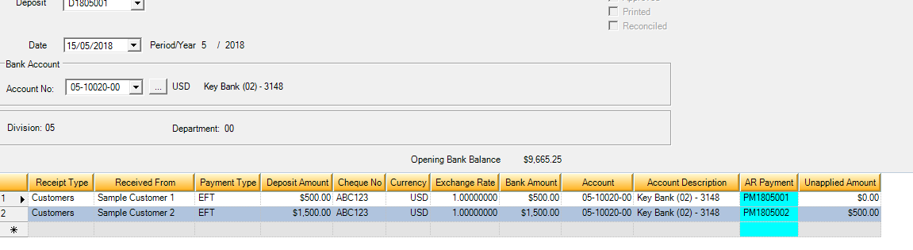

Both have the invoices selected to be paid as per the file as they were open for payment at the time of import.

The deposit is unapproved which allows for further editing if required. Please note one EDI file will produce one deposit and therefore one single entry on the bank subledger for reconciliation purposes. The individual transactions never will appear separate in the destination bank account in Financials.

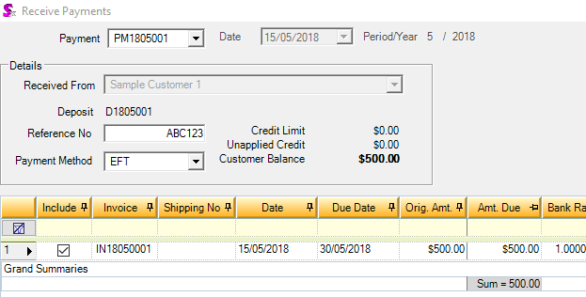

Since there was a comment on the above detail, the memo will show as follows as per the sample

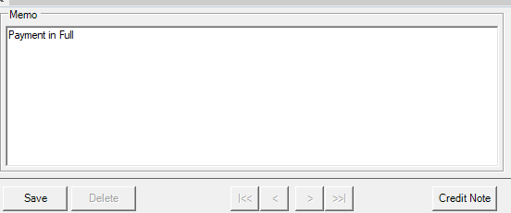

Part 2: Limitations
- Financials deposits are always in the currency of the selected bank account.
- There will be no automatic use of discounts or write off nor any credit that already exists automatically used. This can all be handled once it is imported.
- All records in the file are assumed to be data that needs to be represented as a payment, if reading from a credit card payment system, care must be taken to ensure only records that are considered captures (either Authorization and Capture or Capture).
- Refund of credits are not supported.
- Only customers can have a deposit detail, the import does not support employees or vendors.

Part 3: Out of Scope Elements
- No custom reports, searches, or event alerts will be created with this.

Part 4: Data Setup and Business Process Requirements

Part 5: Objects Affected
Seradex.Win.Financials, Seradex.Financials.FinancialsSystem

Part 6: Data Model Changes
- Deposit Table – New fields – EDI Bit field, EDIFileName varchar(50)

Part 7: Roles and Responsibilities
Solution Stage | Department Owner | Time Cost (hours)
Development | Development | 16

